

**Naan Mudhalvan**

**ServiceNow Administrator**

**Access Control for Project table**

**NAME : Dhanush M**

**Register.No :723621104012**

**Year : IV**

**Semester : 07**

**Access control for Project Table**

**Abstraction:**

* **Access Control for the Project table in ServiceNow involves configuring security mechanisms that govern who can view, create, modify, or delete records within the Project table.**
* **By defining Access Control Rules (ACLs), administrators ensure that sensitive project data is only accessible to authorized users based on roles, permissions, or specific conditions.**
* **These access controls help enforce organizational policies, maintain data privacy, and support compliance requirements. Through appropriate ACL configurations, the system can differentiate between various user groups—such as project managers, team members, and executives—and grant them the right level of access to project-related information.**

**Instructions:**

**Step 1 :Sign in to ServiceNow.**

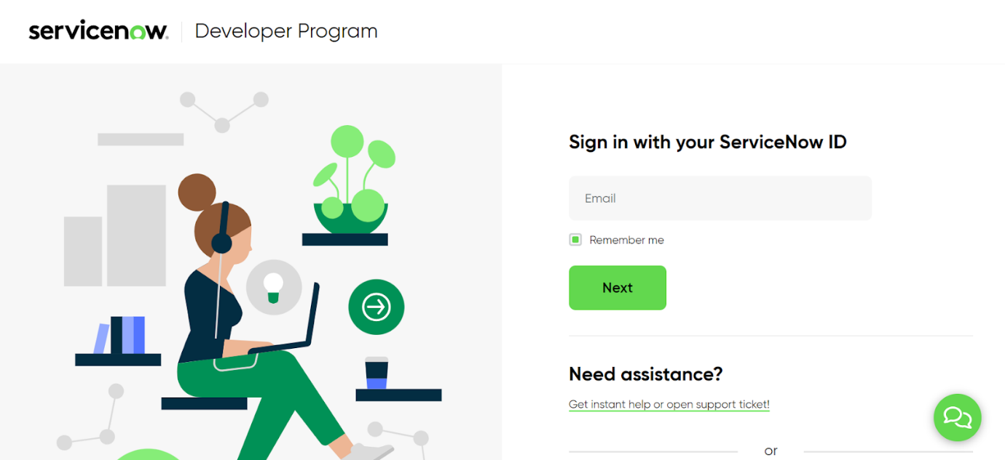

**Step 2 :Sign up for a developer account on the ServiceNow Developer site “**[**https://developer.servicenow.com**](https://developer.servicenow.com/)**”.**

**Step 3 :Once logged in, navigate to the "Personal Developer Instance" section.**

**Click on "Request Instance" to create a new ServiceNow instance.**

**Step 4 :Fill out the required information and submit the request.**

**Step 5 :You'll receive an email with the instance details once it's ready.**

**Step 6 :Log in to your ServiceNow instance using the provided credentials.**

**Now you will navigate to the ServiceNow.**

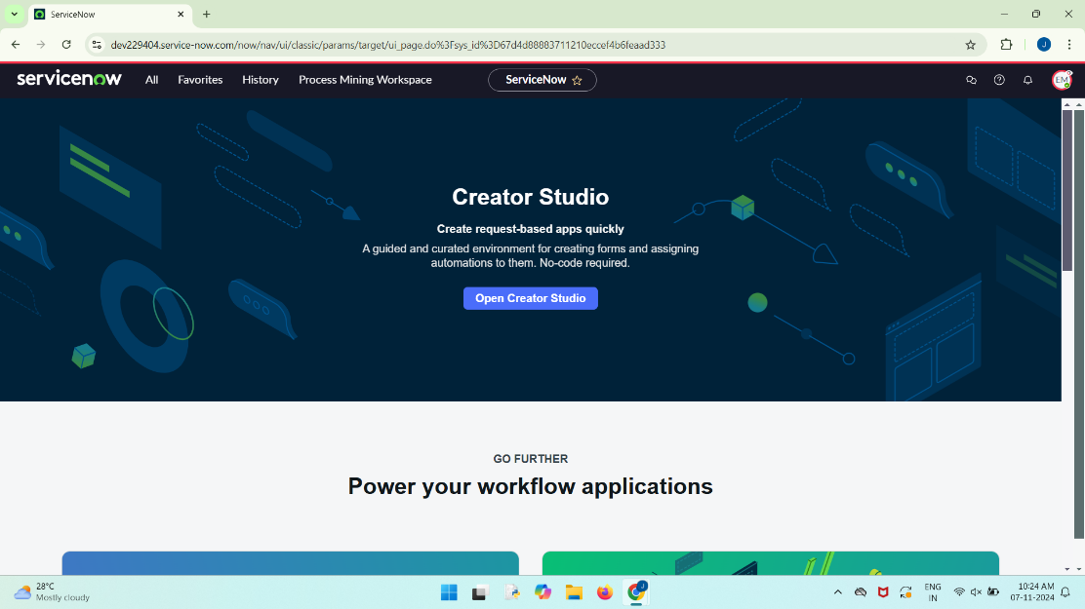

**Step 7 : Open “Tables” >> New.**

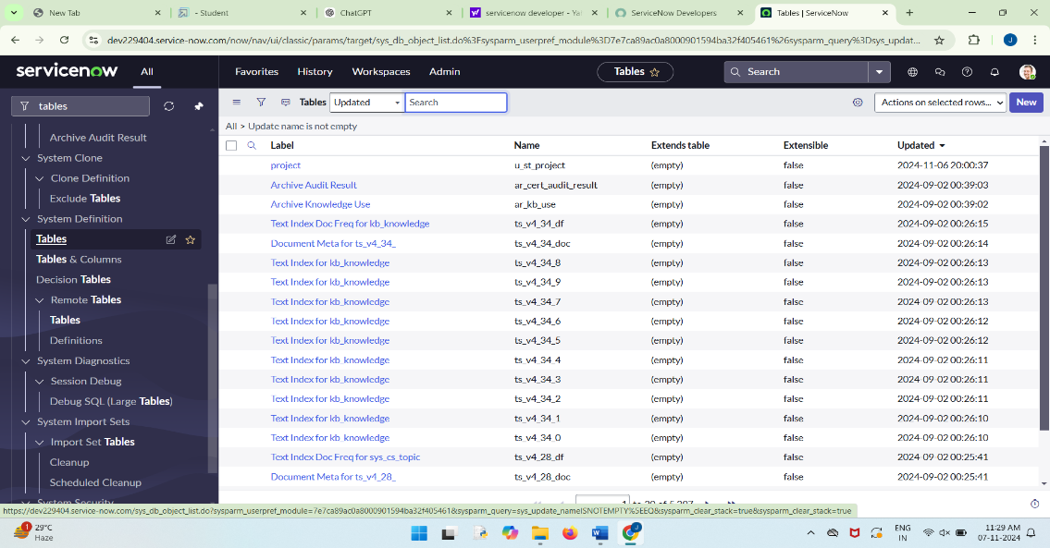

**Step 8 :Fill the details of the table with fields as below >> Save.**

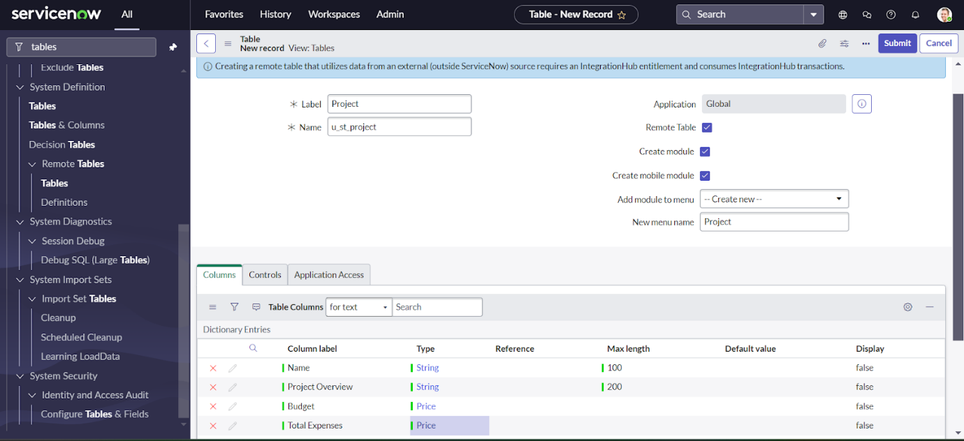

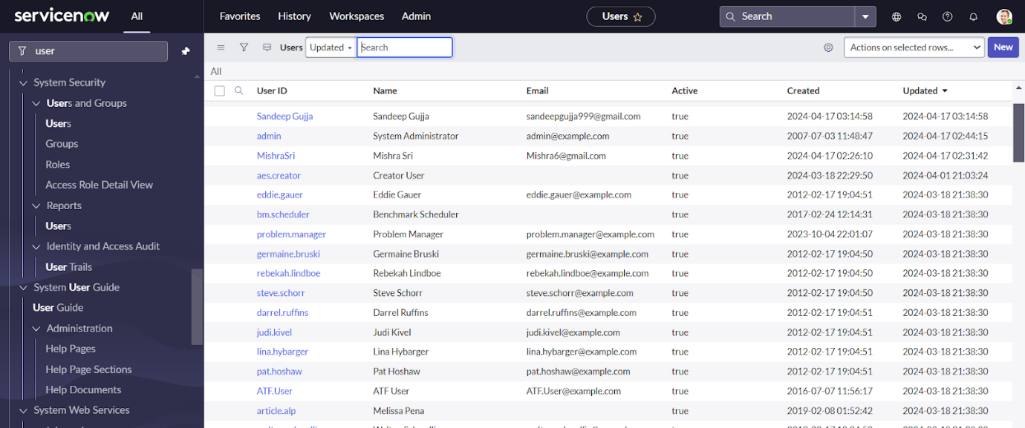

**Step 9 :Open User  >> New.**

**Step 10 :Create Two Users Product Manager and Employe Management.**

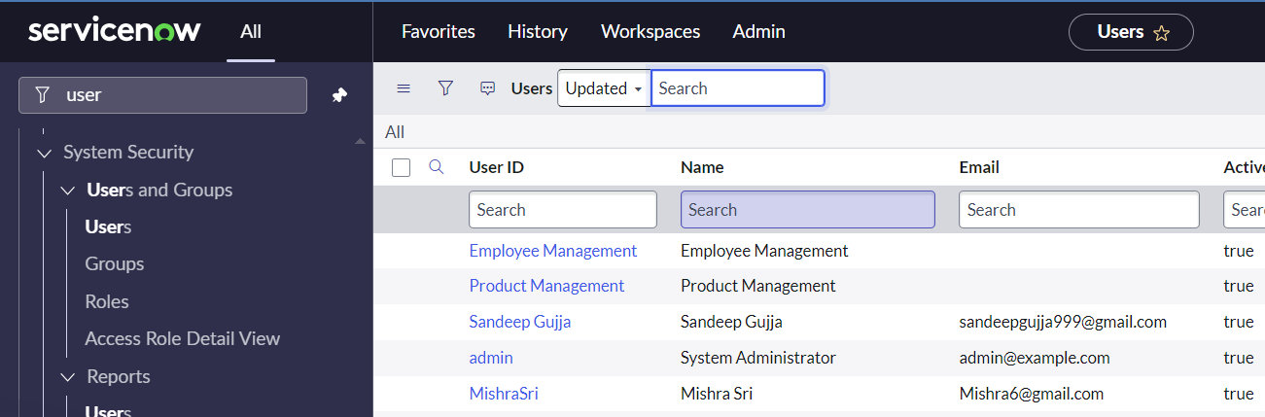

**Step 11 :Open Role >>New**

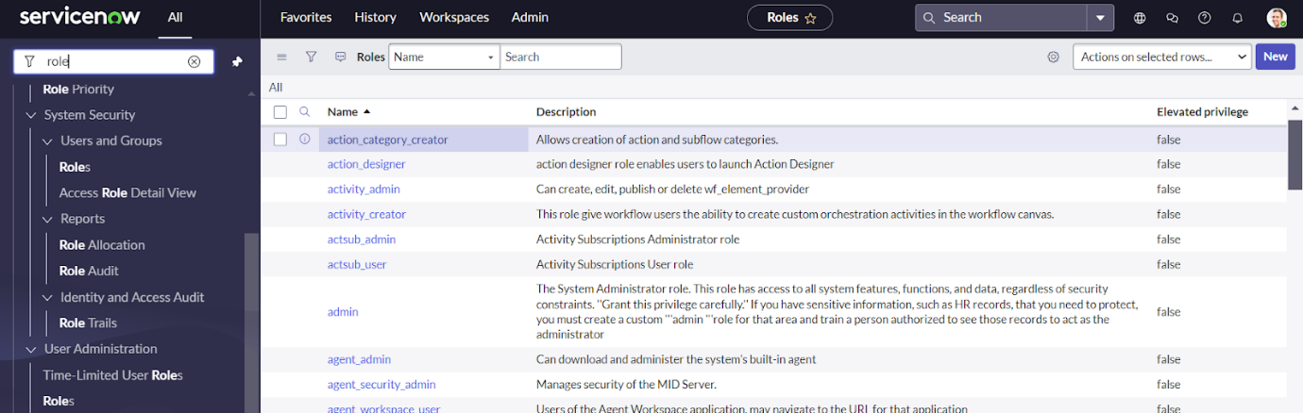

**Step 10 :Create Employee Role.**

**Step 11 :Go to the Project table >> Controls >> copy the role name from the table.**

**Go to Product Management User and add role : u_project_user to it.**

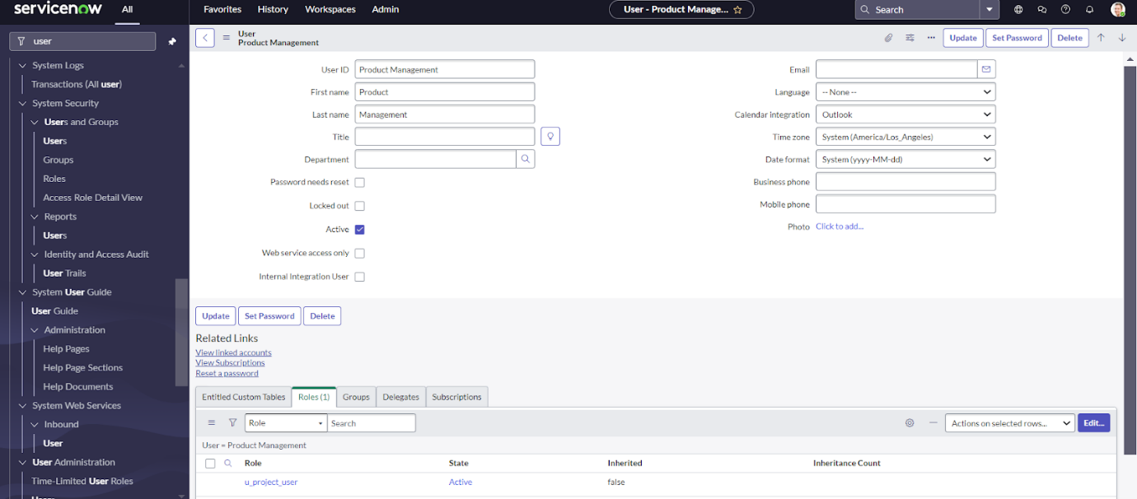

**Step 12 :Go to Employe Management User and add role : Employe role to it.**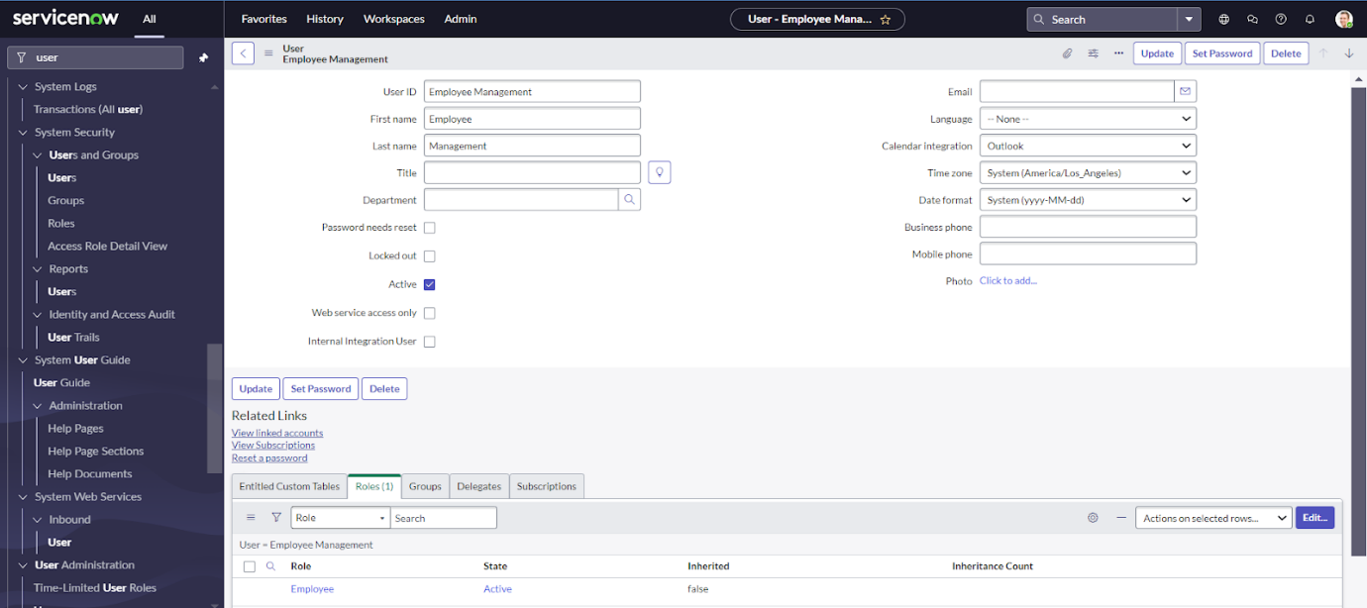

**Step 13 :Click on the Profile avatar >> Elevate Role >> Grant the high security**

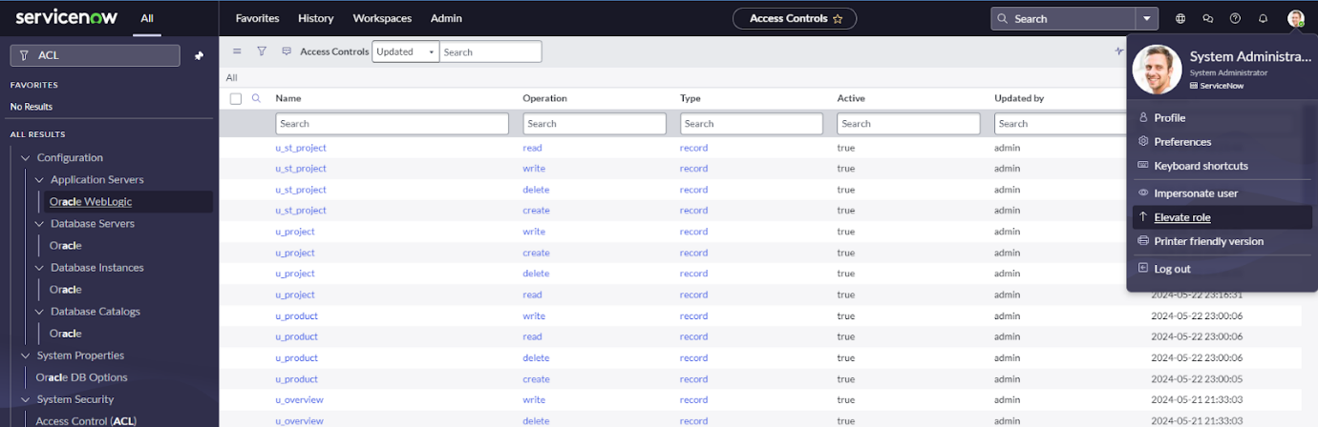

**Step 14 :Search & Open ACL >> New.  
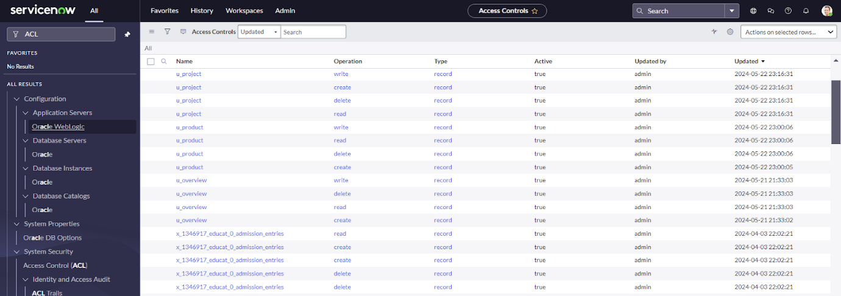**

**Step 15 :Fill the details below andCreate Read Operation Table Level ACL(none) on Employee role >> Save.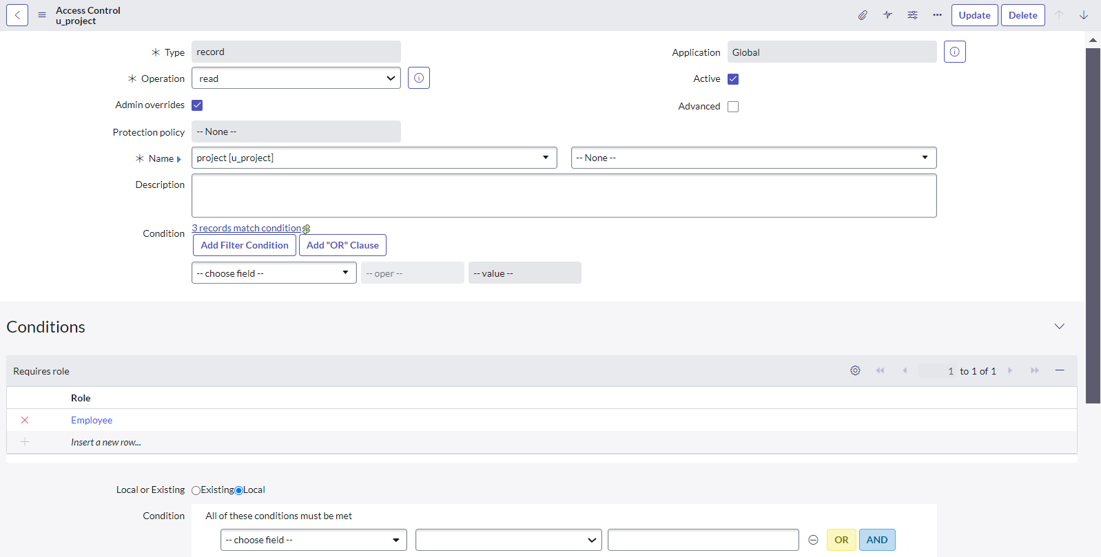Step 16 :New >> Fill the details below andCreate Read Operation Field Level ACL(Budget) on  role: u_project_user >> Save.**

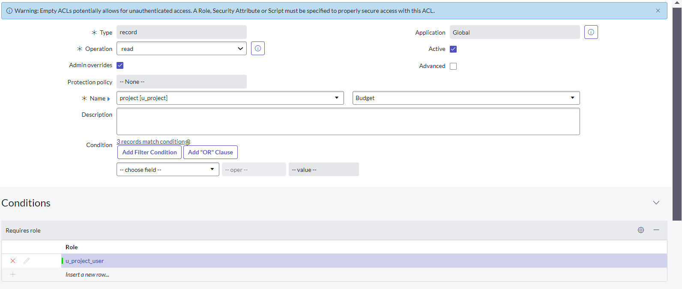

**Step 17 :New >> Fill the details below andCreate Read Operation Field Level ACL(Total Expenses) on  role: u_project_user >> Save.**

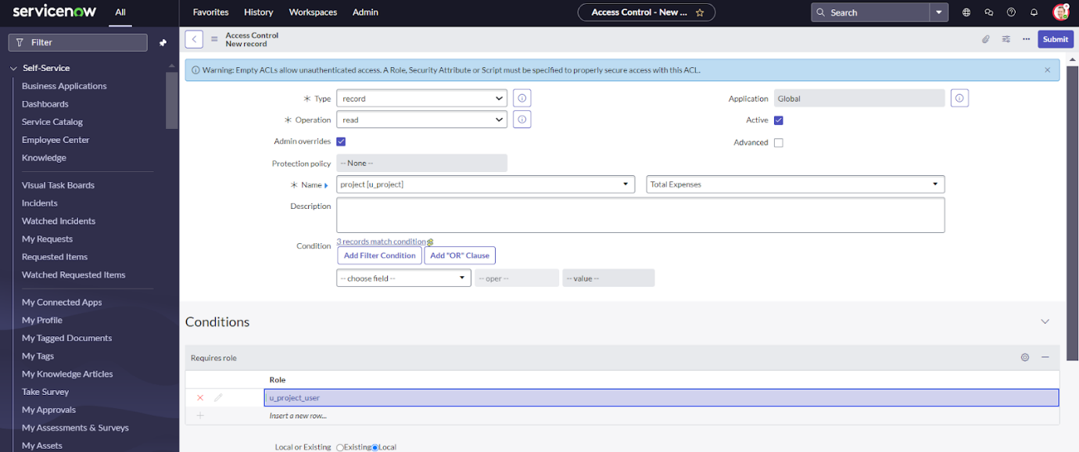

**Step 18 :Impersonate User >> Product Management.**

**Step 19 :All >> Project >> New(We can see that the product Manager has all the CRWD access).  
Step 20 :Create 3 Records with any details .**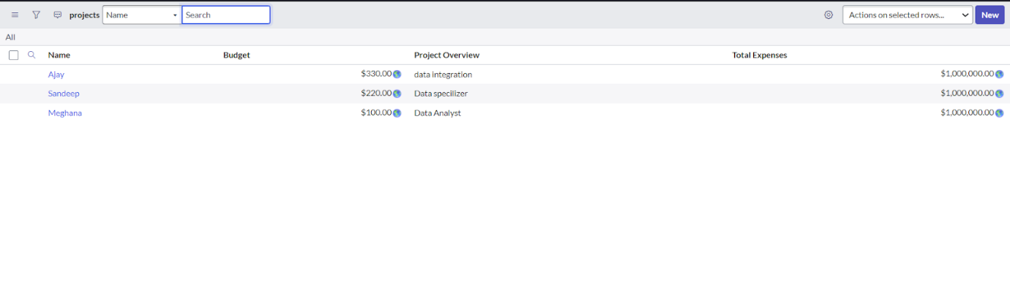

**ScreenShots:**

**Pic 1:**

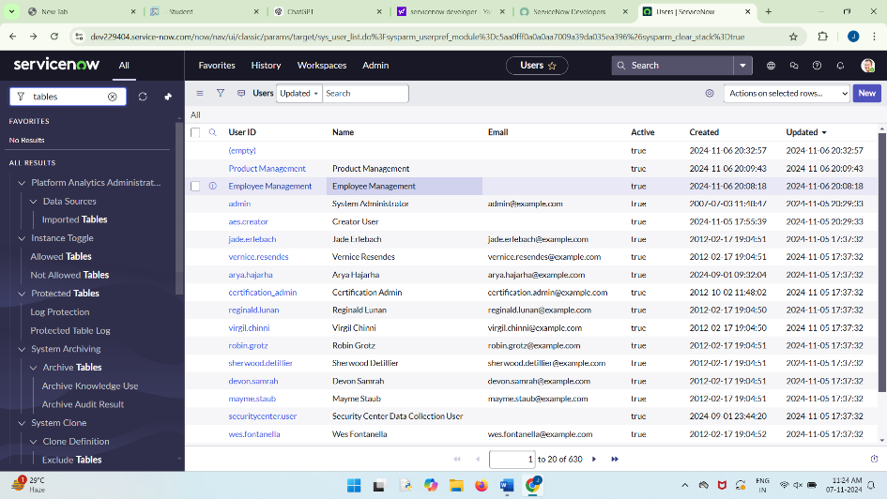

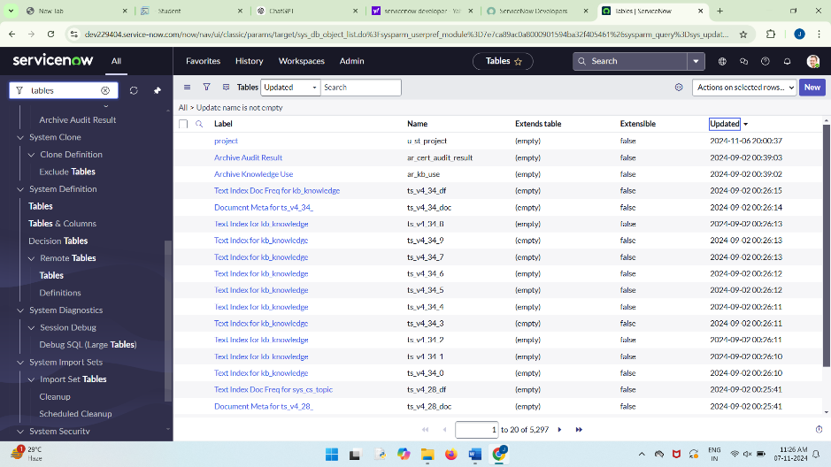**Pic 2:**

**Pic 3:**

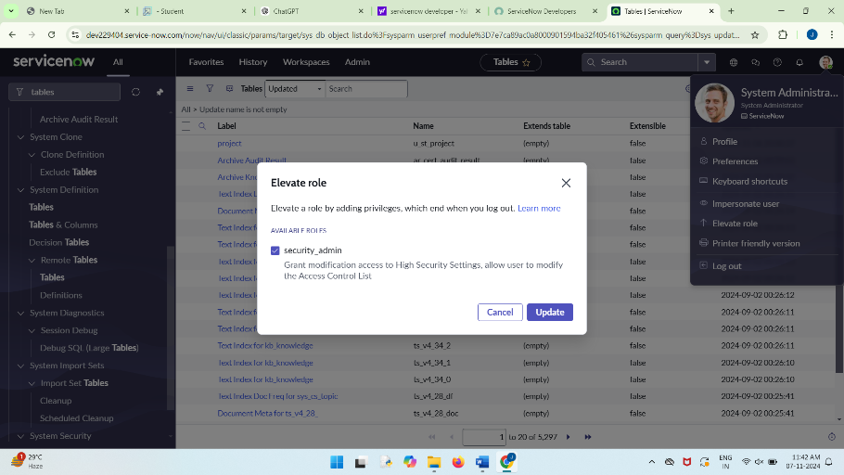

**Result Screenshot**

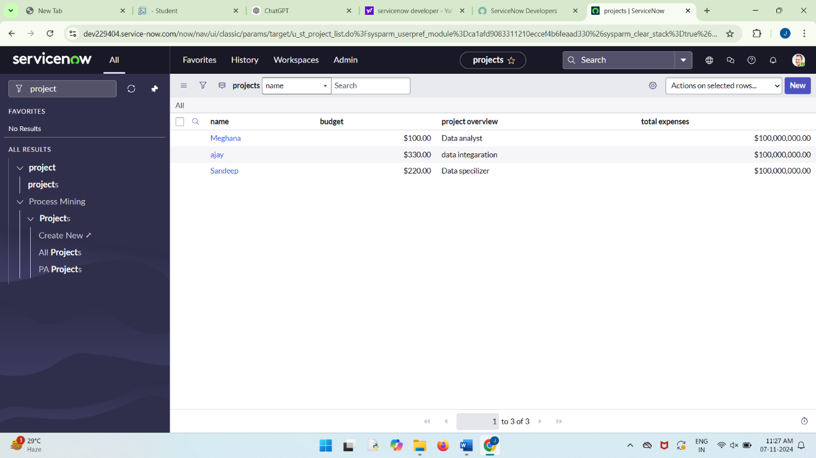

**Demo Video link;**

[**https://drive.google.com/file/d/1cRvBHCQ5yFIGeCLSAi209RxB0wq5wFWv/view?usp=sharing**](https://drive.google.com/file/d/1cRvBHCQ5yFIGeCLSAi209RxB0wq5wFWv/view?usp=sharing)

**Conclusion:**

In conclusion, effective Access Control for the Project table in ServiceNow is crucial for protecting sensitive data and ensuring that only authorized users can access project records. By setting up and managing Access Control Rules (ACLs), organizations can maintain security, promote collaboration, and comply with policies. Properly configured access controls enhance project oversight, boost productivity, and minimize security risks.